***Learning Documentation***

***Hafsa Hashmi / Week 1 Task (Byte wise fellowship)***

***Difference between git & Git Hub?***

They both are common programming tools used to develop different versions of our code and help to collaborate us with other developers. The differences between them are:

|  |  |
| --- | --- |
| Git | Github |
| Purpose: | |
| Manages and keeps track of changes in your code. | Let you host, share, and manage your code files on the internet. |
| Functionality: | |
| Tracks project history, and project versions, manages branches, and facilitates collaboration locally. | Uses Git underneath to manage repositories, and offers additional features like issue tracking, pull requests, and social coding. |
| Usage: | |
| Operates locally on a developer's machine. | Requires internet access to host and share repositories online. |
| Nature: | |
| Open source software. | Proprietary service with both free and paid options. |
| Creator: | |
| Developed by Linus Torvalds in 2005. | Developed by Chris Wanstrath, P. J. Hyett, Tom Preston-Werner, and Scott Chacon, launched in February 2008. |

***2. Git was already installed on my Windows having version:***

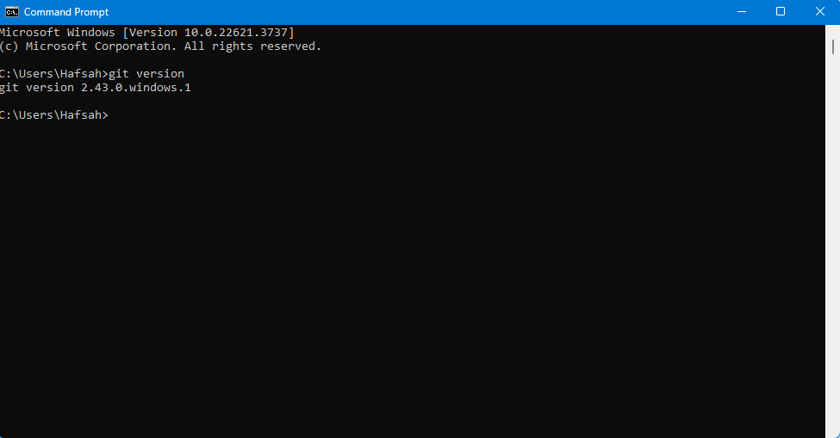

***3. My Github account was already made so the next step is connecting Git it to my Git Hub account:***

git config --global user.name “Hafsah-Hashmi" (Command to set git username)

git config --global user.name (To confirm git username)

git config --global user.email "syedahafsahkhalidhashmi55@gmail.com" (Command to set git user email on local device on cmd/ terminal)

git config --global user.email (To confirm git user email)

***4. Git Cheat Sheet for git hub commands:***

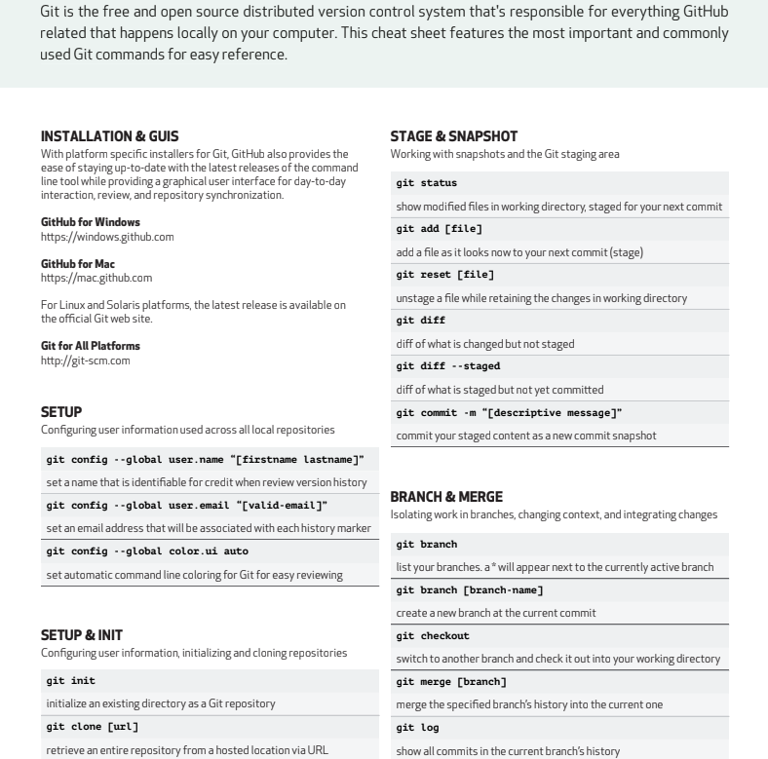

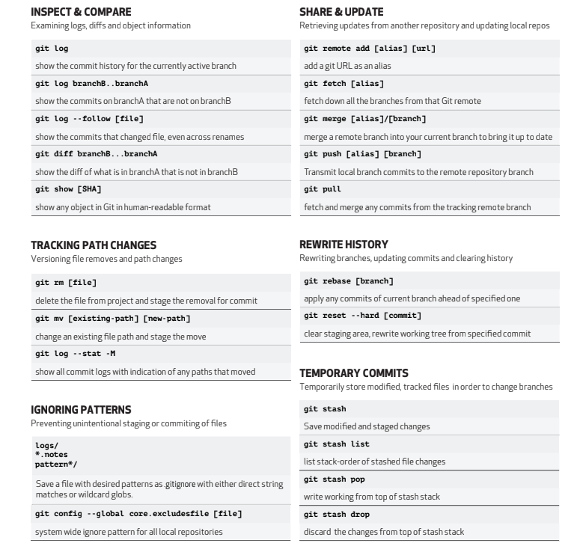

***5. Git Branching***

***What is git branching?***

* Pointer to a snapshot of your changes / Commits and provides the history for changes/ commits you have made.
* Independent line of development
* Default branch – Master

***Why do we need branches?***

* Two features could break code
* Collaboration Purposes:

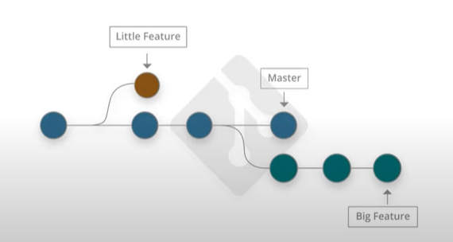

***Creating local and remote branches:***

***Create a local branch using the following command:***

$ git branch new-local-repo

***Create a remote branch using the following command:***

$ git remote add new-remote-repo “link” #add remote repo to local repo config

$git push new-local-repo #pushes the new branch to new-remote-repo

***Creating branches from existing ones:***

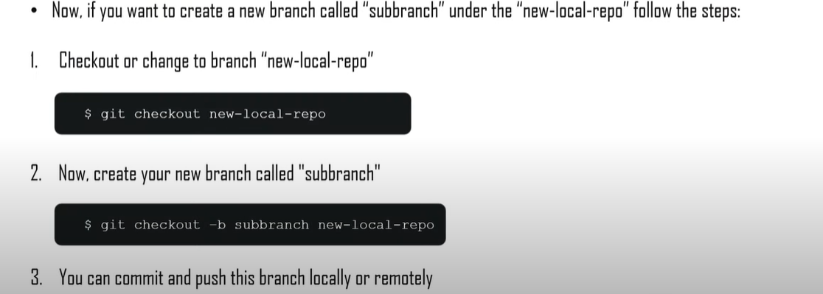

***Switching the branches:***

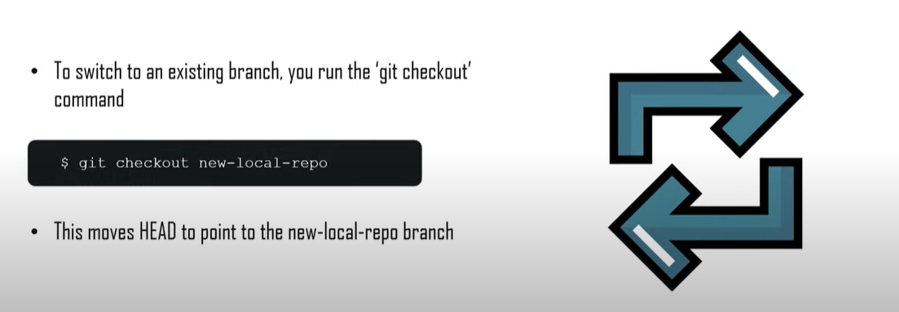

***Deleting the branches:***

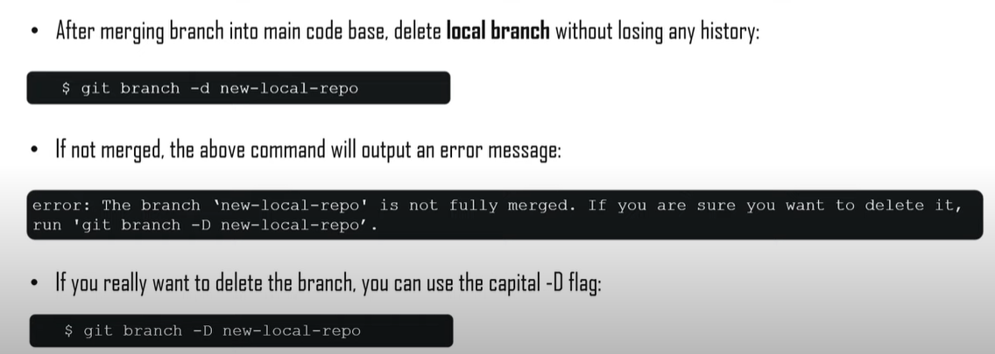

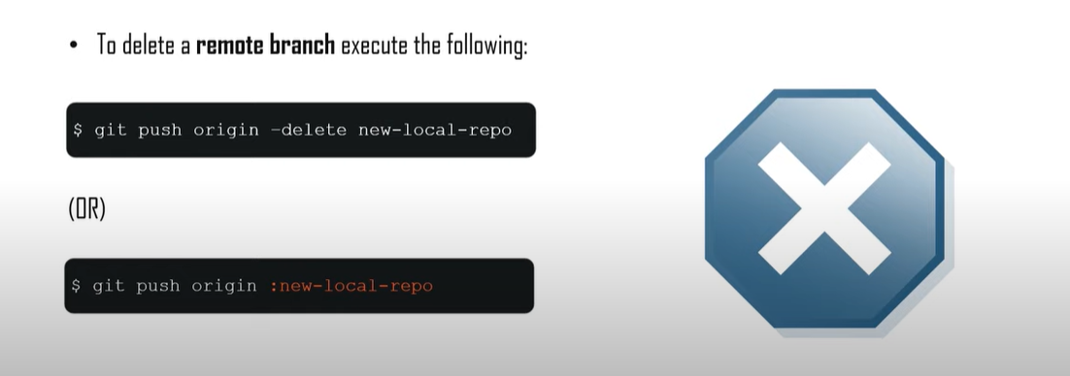

***Common Branching Options:***

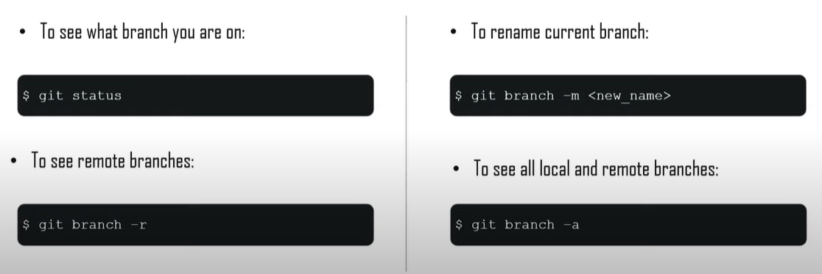

***6. Difference between Data Science vs. Artificial Intelligence vs. Machine Learning vs. Deep Learning***

|  |  |  |  |  |
| --- | --- | --- | --- | --- |
|  | *Artificial Intelligence (AI)* | *Machine Learning (ML)* | *Deep Learning (DL)* | *Data Science(DS)* |
| *Definition* | Broad field focused on creating intelligent systems that perform tasks requiring human intelligence. | A subset of AI involves algorithms that learn from data to make predictions or decisions. | Subset of ML using neural networks with many layers to model complex patterns in data. | Interdisciplinary field using scientific methods to extract knowledge and insights from data. |
|  |  |  |  |  |
| *Goal* | Encompasses ML, DL, NLP, robotics, computer vision, etc. | Includes supervised (Labeled) unsupervised, (non-labeled data), and reinforcement learning (both labeled and non-labeled data) | Specialized in handling large datasets and tasks like image recognition, NLP, etc. | Encompasses data collection, cleaning, analysis, visualization, and interpretation. |
|  |  |  |  |  |
| *Scope* | Create systems that perform intelligent tasks like reasoning, problem-solving, and understanding natural language. | Enable machines to learn from data and improve performance over time. | Automatically discover representations in data through multiple layers of non-linear transformations. | Extract actionable insights from data to inform decision-making and solve complex problems. |
|  |  |  |  |  |
| *Techniques* | Various AI techniques including ML, DL, expert systems, and rule-based systems. | Algorithms like decision trees, support vector machines, and neural networks. | Neural networks like ANNS(data present in the form of numbers), CNNs(Data present in the form of images), RNNs,(Time-series data), and LSTMs. | Techniques from AI, ML, DL, statistics, and domain-specific methods. |
|  |  |  |  |  |
| *Examples:* | AI-powered chatbot that can understand and respond to human queries. | Spam filter that learns to detect spam emails based on past data. | Image recognition system that can identify objects in photos. | Analyzing customer data to identify purchasing patterns and improve marketing strategies. |

Let's try to understand this with the help of an example:

